**40th Austrian Chemistry Olympiad**

**National Competition**

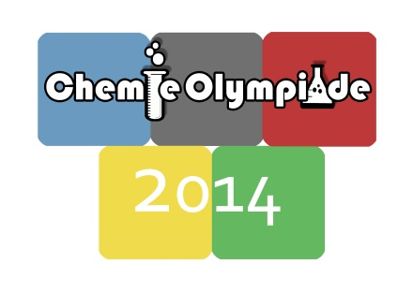



**Practical Part – June 14th, 2014**

**Task 1: ....../39/13**

**Task 2: ....../45/15**

**Task 3: ....../25/12**

**Total: .........../40**

**Name:........................................ Number:............**

## Information

* You have 5 hours to complete the solutions of the competition tasks.
* You may only use this paper, draft paper, a not programmable calculator, a blue or black biro, a pencil, and a ruler, nothing else.
* Write your answers in the boxes provided for them. Only these answers will be marked. If you don’t have enough space, then you may write on the back of the pages with the remark “belongs to part *x.xx*“, whereby *x.xx* means the part of the task in italics. You may take the draft paper with you after the competition.
* This booklet contains 8 pages without the front page.
* You have to wear a lab coat and googles (or your optical glasses) all the time.

**Data and formulae:**

*M* (H) = 1.0 g∙mol-1

*M* (C) = 12 g∙mol-1

*M* (N) = 14 g∙mol-1

*M* (O) = 16 g∙mol-1

|  |  |
| --- | --- |
| Amount of substance | $n=\frac{m}{M}$ |
| Molar concentration | $c=\frac{n}{V}$ |
| Lambert-Beer‘s Law | $A=ϵ∙c∙d$ |

# Task 1 13 points

**Qualitative Analysis**

You are given seven inorganic salts, containing common ions. One of the samples is only soluble in diluted acid, one is totally insoluble, and five samples are readily soluble in water. Two of the salts contain nitrate as anion.

To identify the seven samples, you have the following chemicals at hand:

|  |  |
| --- | --- |
| * ammonia (2M) – „NH3“ * sodium hydroxide (2M) – „NaOH“ * silver nitrate (0.1 M) – „Ag+“ * potassium dichromate (0.003 M) – „Cr“ | * nitric acid (2M) – „HNO3“ * hydrogen peroxide (3%) – „H2O2“ * potassium-sodium carbonate (solid) – „KNa“ |

You may also use chemicals from other experiments!

Other material:

|  |  |
| --- | --- |
| * burner * MgO-rod * funnel * filter paper * pH-paper | * spot test table * nickel spoon * beakers * hot plate magnetic stirrer * Eppendorf-tubes, test tubes, plastic Pasteur pipettes |

*Write the result of your analysis into the table:*

|  |  |  |
| --- | --- | --- |
| **sample** | **cation** | **anion** |
| **1** |  |  |
| **2** |  |  |
| **3** |  |  |
| **4** |  |  |
| **5** |  |  |
| **6** |  |  |
| **7** |  |  |

# Task 2 15 points

**Quantitative Analysis of a Mixture of**

**Potassium dichromate and Potassium permanganate**

**Introduction**

Your task is to determine the percentage of K2Cr2O7 and KMnO4 in a sample without the necessity of seperating the two compounds. An additional problem will be the small concentrations of the two species. It will therefore be impossible to use a conventional wet-chemical method. Instead you will make use of a spectrophotometer to determine the absorbance.

The absorption curves of the two compounds show that for KMnO4 a possible maximum lies at *λMAX* = 545 nm, whereas K2Cr2O7 has a shoulder at *λ* = 427 nm. K2Cr2O7 does not absorb at 545 nm but KMnO4 does at 427 nm.

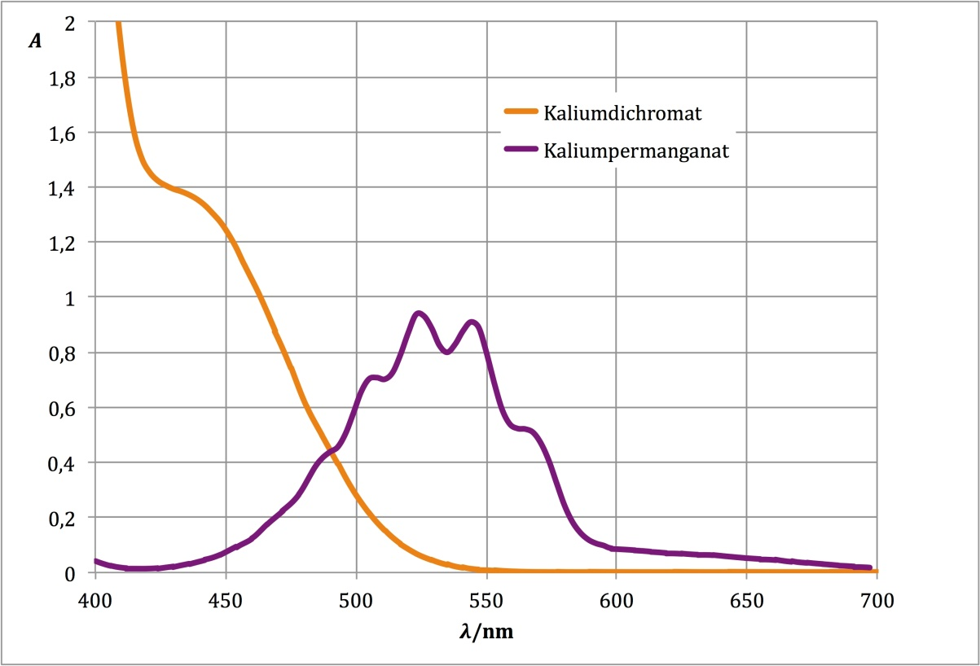

potassium dichromate

potassium permanganate

To calculate the concentrations of the species from the measured absorptions you will need the absorption coefficients. In order to measure these, you need two pure standard solutions of K2Cr2O7 and KMnO4. Unfortunately you don’t know the exact concentrations of the provided standard solutions. So you will need to determine them by iodometric titration.

Summarised you will have to

* determine the concentrations of the standard solutions by iodometric titration
* measure the absorption coefficient of K2Cr2O7 at 427 nm
* measure the absorption coefficient of KMnO4 at 545 nm and 427 nm
* measure the absorbance of your sample at 545 nm and 427 nm
* perform all necessary calculations.

**Tasks**

**a) Determination of the exact concentration of the two standard solutions.**

Determine the exact molar concentrations of the K2Cr2O7- and the KMnO4-standard solutions prepared for you at your work bench. Provided for that task are

|  |  |  |  |
| --- | --- | --- | --- |
| 1 | burette on stand | 1 | PE bottle with dropper with 100 mL Na2S2O3 (0,0100 M) |
| 1 | beaker for waste | 1 | PPP with saturated starch solution „Stä“ |
| 2 | volumetric pipets (10/25) | 1 | numbered glass bottle  (60 mL standard solution of K2Cr2O7 , ≈1-3·10-3 M) |
| 1 | pipette bulb | 1 | numbered glass bottle  (200 mL standard solution of KMnO4, ≈1-4·10-4 M) |
| 1 | titration flask | 1 | PE bottle containing 80 mL H2SO4 (1 M) |
| 1 | kitchen towel | 1 | bottle packed in aluminium foil containing 80 mL solution of potassium iodide (3%) |
| 1 | bottle with deionised water | 1 | test tube with 10 mL-mark |

Pipette 10.0 mL of the potassium dichromate standard solution into the titration flask. Add 10 mL of KI-solution, 10 mL of 1M H2SO4 and some water. Titrate with the thiosulfate solution. Before reaching the end point add a few drops of starch solution.

Pipette 50.0 mL of the permanganate standard solution into the titration flask. Add 10 mL of KI solution, 10 mL 1M H2SO4 and 50 mL of water. Titrate with the thiosulfate solution. Before reaching the end point add a few drops of starch solution.

|  |  |
| --- | --- |
| *2.1. Exact concentrations of the standard solutions* | |
| *Volume of titrant Na2S2O3 (average for dichromate):* | |
| *Volume of titrant Na2S2O3 (average for permanganate):* | |
| *Chemical equation MnO4- - I-:* | |
| *Chemical equation Cr2O72- - I-:* | |
| *Chemical equation S2O32- - I2:* | |
| *Calculation of the concentrations of the standard solutions:* | |
| *c(Cr2O72-) =* | *c(MnO4-) =* |

**b) Determination of the absorption coefficient of Cr2O72-**

Measure the absorbance of two K2Cr2O7 solutions of different concentration. Consider the possibility of diluting the standard solution with water. Fill cuvettes with the solutions to measure and measure against water at 427 nm.

**c) Determination of the absorption coefficient of MnO4-**

Measure the absorbance of two KMnO4 solutions of different concentration. Consider the possibility of diluting the standard solution with water. Fill cuvettes with the solutions to measure and measure against water at 545 nm and 427 nm.

|  |  |  |
| --- | --- | --- |
| *2.2. Absorption coefficient of dichromate at 427 nm* | | |
| *K2Cr2O7- solution 1* | *K2Cr2O7- solution 2* |  |
| *c =* | *c =* |  |
| *A =* | *A =* |  |
| *ε =* | *ε =* | *ε(average) =* |
| *2.3. Absorption coefficient of Permanganate at 545 nm* | | |
| *KMnO4- solution 1* | *KMnO4- solution 2* |  |
| *c =* | *c =* |  |
| *A =* | *A =* |  |
| *ε =* | *ε =* | *ε(average) =* |
| *2.4. Absorption coefficient of Permanganate at 427 nm* | | |
| *KMnO4- solution 1* | *KMnO4- solution 2* |  |
| *c =* | *c =* |  |
| *A =* | *A =* |  |
| *ε =* | *ε =* | *ε(average) =* |
| *Show the calculations of the concentration and the absorption coefficient using one example:* | | |

**d) Measurement of the absorbance of the sample**

For measuring the absorbance of your sample hand the test tube 16x160 (labeled with „PNo“ and your place number) to the lab assistant. He will fill in your sample. Immediately measure the absorbances at 427 nm and 545 nm against water.

For tasks b), c) and d) you have at your disposal:

|  |  |  |  |
| --- | --- | --- | --- |
| 2 | 5/10 mL graduated pipettes | 1 | standard solution of K2Cr2O7 (≈1-3·10-3 M) |
| 1 | beaker for waste | 1 | standard solution of KMnO4 (≈1-5·10-4 M) |
| 1 | pipette bulb | 8 | plastic cuvettes (*d* = 1,0 cm) |
| 4 | test tubes 16×160 | 1 | bottle of deionised water |
| 1 | kitchen towel | 1 | empty test tube 16×160 labelled „PNo“ for gathering your sample |
| 1 | pen for labeling glass |

|  |  |
| --- | --- |
| *2.5. Concentrations of KMnO4 and K2Cr2O7 in the sample* | |
| *A427 (sample) =* | *A545 (sample) =* |
| *c(Cr2O72-) =* | *c(MnO4-) =* |
| *Show your calculations:* | |

# Task 3 12 points

**Synthesis of 1,4-dihydro-2,6-dimethylpyridine-3,5-dicarboxylic acid diethyl ester**

**(Hantzsch-ester)**

**1. Principle**

1,4-Dihydropyridine and its derivatives (1,4-DHPs) are ubiquitous in nature and are also used in medicine in various fields. Recently, 1,4-DHPs have played a new role in organic chemistry – as alternative hydrogen sources.

The above mentioned Hantzsch ester is easily synthesized in a one-pot multi-component reaction, starting from commercially available reagents, according to the following scheme.



**2. Procedure:**

a) Synthesis:

Pour 50 mL of water into a 100-mL-Erlenmeyer flask which already contains 1.30 g ethyl acetoacetate. Add 1 g of ammonium carbonate (test tube „NH4“) and shake the mixture until it has become homogeneous. Add 7 g of hexamethylenetetramine (urotropine, test tube „U“), a magnetic stirring bar, a thermometer and heat the mixture to 70-80ᵒC on a hot-plate magnetic stirrer while stirring constantly. Keep the mixture at this temperature for 45 minutes (it is possible that some solid precipitates during reaction time). Cool the mixture to room temperature by removing from the hot plate. Put the reaction mixture into an ice-bath for about 10 minutes to complete precipitation.

Filter the raw material through a Büchner funnel under reduced pressure, wash the solid twice with small portions of water (about 5 mL each time) and suck to dryness for a few minutes.

Put a few crystals of the raw material into the Eppendorf tube „2“ for TLC analysis.

b) Recrystallization:

Put the raw material in the 100-mL-Erlenmeyer flask. Add 20 mL cyclohexane (test tube „Cyc“, contains 20 mL) and heat on the hot plate to boiling (use a boiling stone). While boiling, add ethyl acetate drop wise with a Pasteur-pipette until all the product has dissolved. Cool to room temperature in a water bath followed by scratching until crystallization starts. In order to complete crystallization cool additionally in an ice bath for other 10 minutes. Filter the product through the Büchner funnel by suction under reduced pressure. Suck to dryness. Transfer the product to a pre-weighed watch glass and hand it over to the lab assistant for drying which will be done at 80°C for 15 minutes.

Determine yield and melting point of your product.

Put a few crystals into the Eppendorf tube „3“ for TLC analysis.

|  |
| --- |
| *3.1. Hand in the product on the watch glass.* |

|  |
| --- |
| *3.2. Calculate the theoretical yield:* |
| *Calculation:* |

|  |
| --- |
| *3.3. Calculate your yield in % of the theory.* |
| *Calculation:* |

|  |
| --- |
| *3.4. Melting point of your product:* |

c) Thinlayer chromatography (TLC):

The Eppendorf tube „1“ contains 1 drop of ethyl acetoacetate.

Add 2-3 drops of acetone with a Pasteur pipette to each of the 3 Eppendorf tubes for dissolving the contents. Using capillaries spot the samples onto the TLC-plate (silicagel with fluorescence indicator 254). The TLC plate is developed using heptane:ethyl acetate = 2:1 as mobile phase.

|  |
| --- |
| *3.5. Mark all your spots by circling with a pencil, also mark the starting line and the front line. Hand in the TLC plate (with your number on it).* |

|  |
| --- |
| *3.6. Calculate the Rf-values.* |
| *Rf of ethyl acetoacetate:*  *Rf of raw product:*  *Rf‘ of recrystallized product:* |