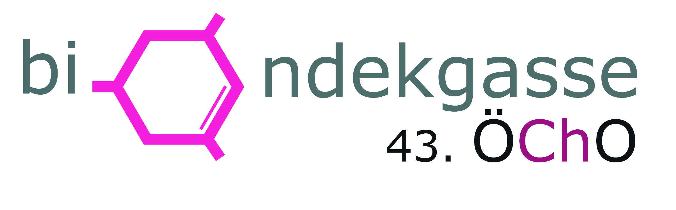

43rd Austrian Chemistry Olympiad

National Competition

Theoretical Tasks

2017-05-25

|  |
| --- |
| Name |

|  |  |  |  |  |  |  |
| --- | --- | --- | --- | --- | --- | --- |
|  |  | bp | / | rp | / | rpmax |
| 1 | Bicyclic Nitrogen Compounds and their Syntheses |  | / |  | / | 16 |
| 2 | Pharmaceuticals, Stereochemistry and Spectroscopy |  | / |  | / | 8 |
| 3 | Aluminium and Complexes |  | / |  | / | 7 |
| 4 | Aluminium, Chemical Bond and Thermochemistry |  | / |  | / | 8 |
| 5 | Sulfur Compounds, Kinetics and Elektrochemistry |  | / |  | / | 7 |
| 6 | Lead, Calcium and Equilibrium |  | / |  | / | 7 |
| 7 | Fuel and Otto Engine |  | / |  | / | 7 |
| Total: | | | |  | / | 60 |

Important notes

* You have got 5 hours time to solve the tasks.
* You are allowed to use:
  + a non-programmable calculator
  + a periodic table
  + a sheet with formulae
  + draft paper
  + writing untensils
* Only the answers in the boxes will be marked.
* When calculations are requested you should write them into the boxes in a comprehensible way. Please, underline final results.

Task 1 16 points

Bicyclic Nitrogen Compounds and their Syntheses

This task deals with derivatives of tropane, the so-called tropane alkaloids. Tropane is a bicyclic amine and is named 8-Methyl-8-aza-bicyclo[3.2.1]octane.

These natural compounds are formed by plants, especially by Solanaceae, as a protection against natural enemies.

Tropane alkaloids have a wide range of pharmacological activities, thus science has been involved in various syntheses of these compounds for around 100 years.

The first part of the task deals with the synthesis of atropine, the poison of deadly nightshade. The second part is about ferruginine, an agonist of nicotinic acetylcholine receptors.

**A. Synthesis of atropine**

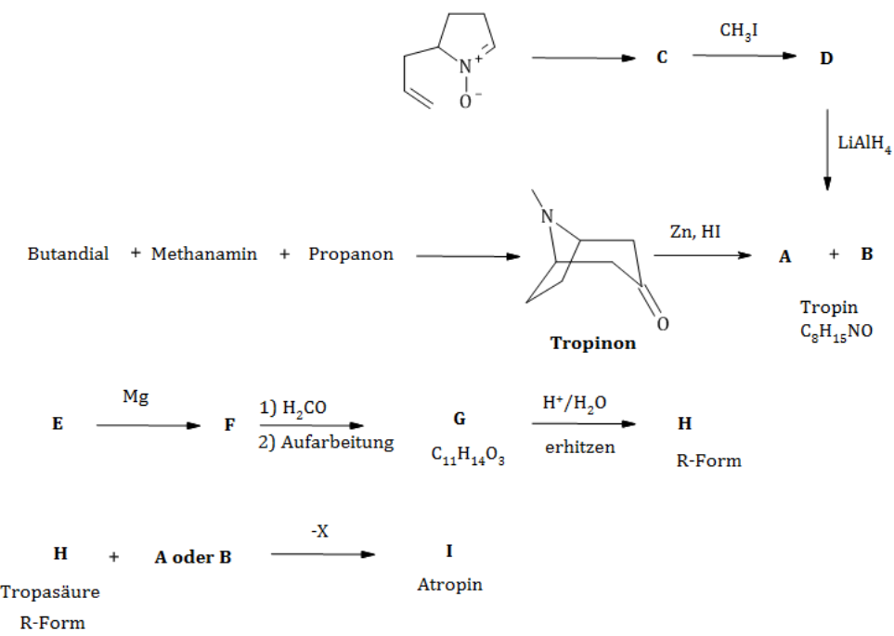

Use the following hints to solve the task:

* Compound **E** is called Ethyl-2-bromo-2-phenylethaneoat.
* **A** und **B** are stereoisomers.

|  |  |
| --- | --- |
| 1.1 Draw the configuration formulae of the compounds **A**, **B** and **H** and the constitutional formulaeof the compounds **C, D, F, G, I** and chemical formula of **X.** | |
| A | B |
| C | D |
| E | F |
| G | H (R-configuration) |
| I | X |

|  |
| --- |
| 1.2 Write the mechanism of the reaction **F→G.** Name the corresponding reaction type. |
| **Type of reaction:** |

|  |
| --- |
| 1.3 Name the type of stereoisomerism that occurs in **A** and **B**. |
|  |

|  |
| --- |
| 1.4 Draw arrows in the structural formula in the starting material leading to compound **C**, which clarify the formation of **C**. Name the occurring reaction type. |
| **Type of reaction:** |

**B. Synthesis of ferruginine**

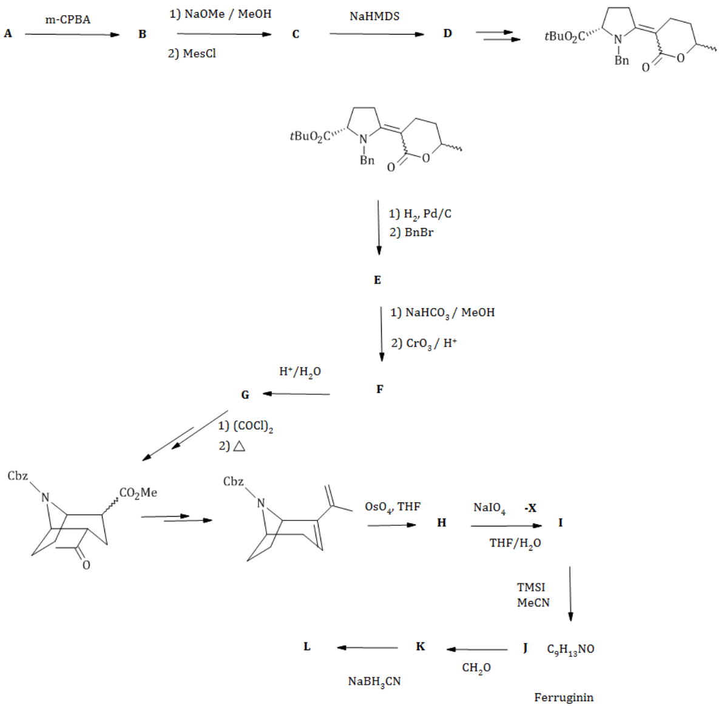

Use the following hints to solve the task:

* Compound **A** is called 2-Methylcyclopentaneon according to IUPAC.
* Reaction **C** → **D** is leading to a reactive intermediate.
* The methyl ester function is retained in reaction **F** → **G**.
* A protecting group is exchanged for another one in step **G** to the bicycles.
* There is no reaction within the cyclus in step **H** → **I**, the replaced molecule **X** has a molar mass of 30.03 g/mol.
* Abbreviations:

Bn = benzyl, Cbz = benzyl (benzyloxycarbonyl), Mes = mesyl = methanesulfonat,   
TMSI Trimethylsilyliodid, NaHDMS = [(CH3)3Si]2NNa

|  |  |
| --- | --- |
| 1.5 Draw the configurational formulae of **A**, **B** und **H** and the constitutional formulae of the compounds **C**, **D, E, F, G, I, J, K, L** and **X.** | |
| A | B |
| C | D |
| E | F |
| G | H |
| I | J |
| K | L |
| X |  |

Task 2 8 Punkte

Pharmaceuticals, Stereochemistry and Spectroscopy

A: Pharmaceuticals

Characteristic 13C-NMR Chemical Shifts:

|  |  |  |  |
| --- | --- | --- | --- |
| **Type of C**  **(R= Alkyl, Ar = Aryl)** | **Chemical Shift (ppm)** | **Type of C**  **(R= Alkyl, Ar = Aryl)** | **Chemical Shift**  **(ppm)** |
| R**C**H3 | 10 – 25 | R**C≡**CR | 65 - 85 |
| R**C**H2R | 20 – 35 | RCH=**C**HR | 120 - 140 |
| R3**C**H | 25 – 35 | Aryl **C** | 120 - 140 |
| R**C**H2COR | 35 – 50 | R**C**OOR | 160 - 180 |
| R**C**H2Br | 25 – 35 | R**C**ONR2 | 165 - 180 |
| R**C**H2Cl | 40 – 45 | R**C**OOH | 175 - 185 |
| R**C**H2NH2 | 30 – 65 | R**C**HO | 190 - 205 |
| R**C**H2OH | 60 - 70 | R**C**OR | 200 - 215 |
| R**C**H2OR | 65 - 70 |  |  |

When it comes to chiral centers, one usually thinks of carbon atoms. But also the sulfur atom of a sulfinyl group (S = O) can be present in R- or S-configuration. It contains a free electron pair that is assigned lowest priority according to CIP sequence rules. The sulfur atom of the sulfoxide cannot vibrate through the plane of its bonding partners, which is why it is a chiral center as soon as those are different.

Adrafinil is a racemic psychostimulant. Its constitutional formula is shown below. It contains a chiral center.

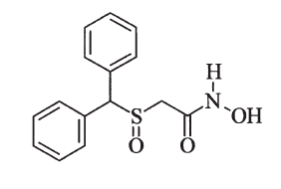

|  |  |
| --- | --- |
| 2.1. Draw the configuration formulae into the boxes as appropriate. | |
| *S – Enantiomer:* | *R – Enantiomer:* |

13C-NMR spectrum of Adrafinil in CDCl3:

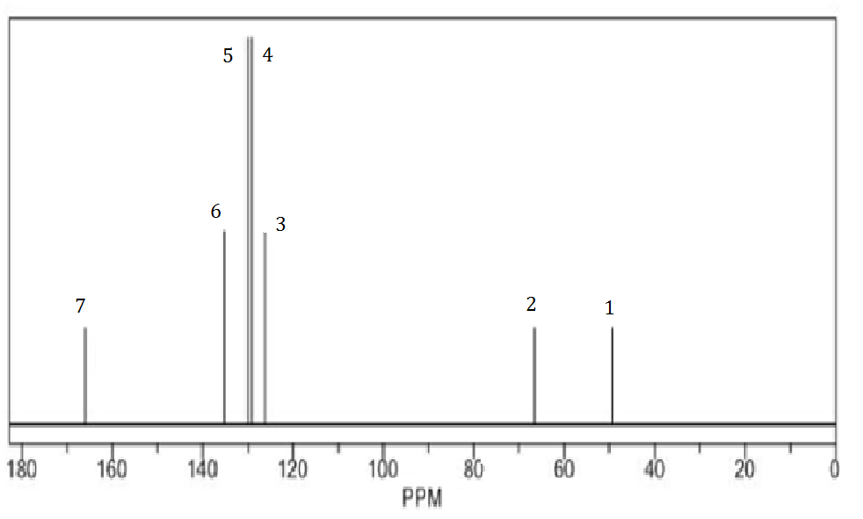

|  |
| --- |
| 2.2 Assign all signals of the 13C-NMR spectrum to the corresponding C atoms of Adrafinil. For that purpose, assign each carbon atom of the configuration formula below the corresponding number (1 to 7). |
|  |

1H-NMR spectra have been recorded of Adrafinil and 2-[(Diphenylmethyl)-sulfonyl]acetamide, both in CDCl3. Unfortunately, the two spectra (referred to as "Spectrum1" and "Spectrum 2" on the next page) have been mixed up, so that it is no longer clear which one belongs to which compound.

Constitution of 2-[(Diphenylmethyl)sulfonyl]acetamide:

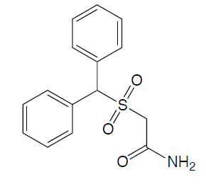

Spectrum 1:

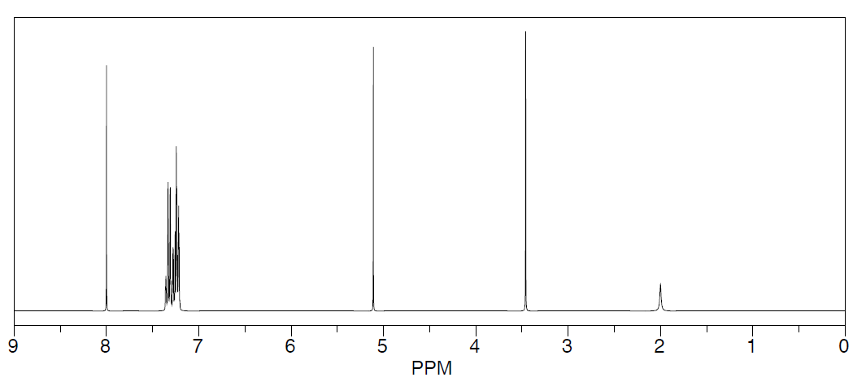

Spectrum 2:

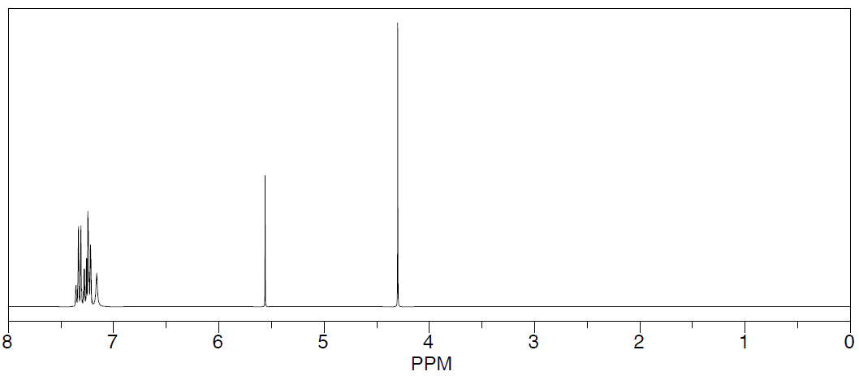

|  |
| --- |
| 2.3 Write the number of the 1H-NMR spectrum of Adrafinil into the box below. Assign chemical shifts in ppm to at least two different protons in the constitutional formula below to clearly justify your selection of spectrum. |
| Spectrum No.: |
| Assignment: |

|  |
| --- |
| 2.4 Assume that the solvent is replaced by CD3OD. Does the spectrum still contain all signals in this case? If „no“: Draw the resulting – changed – constitutional formula. |
| O yes O no (tick the correct answer) |
|  |

Vedaclidine, an analgesic, and alfoqualone, a muscle relaxant, are also chiral compounds.

|  |
| --- |
| 2.5 Mark the chiral center(s) with an asterisk. Furthermore, state the absolute configuration(s) of Vedaclidine by assigning the correct stereo descriptor to the respective center(s). |
| Vedaclidine |

Alfoqualone 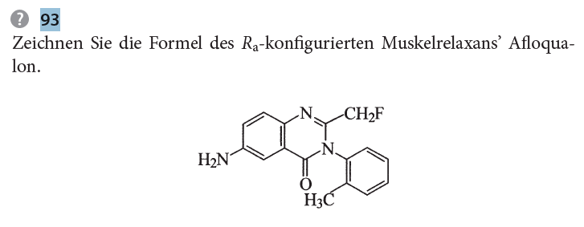

|  |
| --- |
| 2.6 State the reason, why afloqualone is chiral. |
|  |

|  |
| --- |
| 2.7 Draw the configuration formula of afloqualone and state the corresponding stereo descriptor(s). |
|  |

The 13C-NMR spectrum of linezolid, an antibiotic of the oxazolidinone group, is given below:

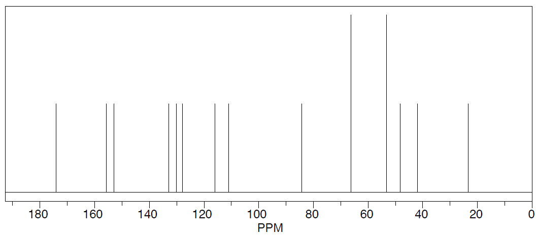

|  |
| --- |
| 2.8 Explicitly mark those C atoms in the formula of linezolid that lead to the same signal in 13C-NMR and state how many signals in the spectrum are caused by more than one C atom. |
| *Number of signals from more than one C atom:* |
| *Linezolid:* |

B: An unknown compound

0.5000 g of an unknown compound was subjected to elemental analysis. At a pressure of 1.0135 bar and a temperature of 25 °C, 683.9 cm3 of CO2 and 0.323825 g of H2O were formed. The compound has a molar mass of around 250 g/mol. The IR spectrum, the 1H NMR spectrum and data from 13C NMR analysis are given below.

|  |
| --- |
| 2.9 Calculate the molecular formula of the unknown compound: |
|  |

Data from 13C-NMR analysis: 13.6; 35.7; 57.8; 59.5; 125.3; 127.6; 128.7; 141.1; 174.5 ppm

IR spectrum:

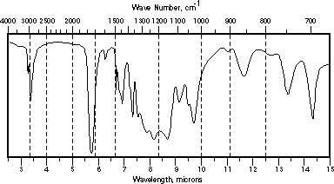

1H-NMR spectrum:

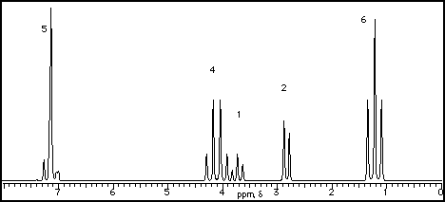

|  |
| --- |
| 2.10 Draw the constitutional formula of the unknown compound. Clearly assign each signal of the 1H NMR spectrum to a proton in the molecule by assigning lower-case letters a, b, c, etc. both to the peaks in the spectrum and the corresponding protons of the constitutional formula. |
|  |

Task 3 7 points

Aluminum and Complexes

Aluminum crystallizes in cubic closest packing of spheres and can be described as fcc aluminium. It has a density of *ρ* = 2.699 g/cm3. Nowadays aluminium can be rolled out to foils reaching thicknesses of 0.004 mm.

|  |
| --- |
| 3.1 Draw spheres representing Al atoms into the unit cell below so that they reach cubic closest packing. |
| C:\Users\Katharina\AppData\Local\Microsoft\Windows\INetCacheContent.Word\EZ.PNG |

|  |
| --- |
| 3.2 Calculate the lattice parameter a in pm. |
|  |

Aluminum is easily soluble in hot concentrated hydrochloric acid, forming [Al(H2O)6]3+ ions. At room temperature, aluminium can be dissolved in strong bases and forms [Al(OH)4]− ions. Hydrogen is released in both cases.

|  |  |
| --- | --- |
| 3.3 Assign the correct systematic names to the ions formed during both processes: | |
| [Al(H2O)6]3+ | Name: |
| [Al(OH)4]- | Name: |

|  |
| --- |
| 3.4 Give the reaction equations of both dissolution processes mentioned above: |
|  |
|  |

Bauxite is an important raw material for the production of metallic aluminium. This aluminium ore consists of aluminium oxide-hydroxide AlO*x*(OH)3-2*x*. (0 <x <1)

In order to convert bauxite into sufficiently pure aluminium oxide, the Bayer process is used. At higher temperatures, sodium hydroxide solution is added to bauxite, whereby aluminium hydroxides easily dissolve leaving behind undissolved residue, "red mud". Typical, industrially used bauxites contain SiO2, Fe2O3, TiO2, P4O10, etc. besides Al2O3 .

|  |
| --- |
| 3.5 Complete the following reaction equations of the Bayer process by inserting correct stoichiometric coefficients and missing species, if necessary. |
| Al2O3 + OH- + ⟶ [Al(OH)4(H2O)2]- |
| SiO2 + OH- ⟶ |
| + ⟶ + |
| [Al(OH)4(H2O)2]-  ⟶ + OH- + H2O |
| Al(OH)3 ⟶ Al2O3 + |

Aluminum oxide appears in various modifications. Rhombohedral α-Al2O3 doped with Chromium is known as „ruby“. The red color of the ruby can be traced back Cr3+ ions in the crystal. Besides its use as a gemstone, synthetic, monocrystalline ruby is utilised in lasers. Consider a rod made of ruby that is 15.2 cm long and has a diameter of 1.15 cm. It contains a mass fraction of 0.050% (m/m) Cr3+ ions. The density of alumina is =4.05 g / cm3.

|  |
| --- |
| 3.6 Calculate the number of Cr3+ ions in this rod of ruby. |
|  |

Cr3+ ions in ruby are octahedrally coordinated by 6 oxygen ions, which leads splits the energy levels of the 3d-orbitals. The image below shows the shapes of the 3d-orbitals as well as the split energy levels.

|  |
| --- |
| 3.7 Write into each of the predefined box, whether the orbital in question belongs to the t2g‑ or the eg- orbitals. |
|  |

|  |
| --- |
| 3.8 Fill up the d-orbital scheme of Cr3+ by using arrows for each electron in the usual way. |
|  |

A large variety of isotopes of aluminium exist, showing different modes of decay and varying half lives. Of these, only 27Al is stable. 24Al has a half life of around 2.05 s and shows + decay followed by  decay to yield a stable nuclide.

|  |
| --- |
| 3.9 Give equations for both nuclear reactions of 24Al decay. |
|  |
|  |

The age of a fossilized human bone or a meteorite can be determined indirectly by so-called “surface exposure dating”. Among others, this method relies on electron capture by 26Al.

|  |
| --- |
| 3.10 Write the nuclear reaction scheme for this electron capture process. |
|  |

Task 4 8 points

Aluminium, Chemical Bonds and Thermochemistry

The so called transport reaction is one possibility to purify aluminium. In this reaction gaseous aluminium(III) chloride is directed over liquid aluminium. In the gas phase at elevated temperatures AlCl is formed. AlCl decomposes at lower temperatures yielding pure Al.:

2 Al(l) + AlCl3 (g) ⇌ 3 AlCl(g)

|  |  |  |
| --- | --- | --- |
|  |  |  |
| Al(l) | 10.56 | 39.55 |
| AlCl3(g) | -584.59 | 314.44 |
| AlCl(g) | -51.46 | 227.95 |

|  |
| --- |
| 4.1 Calculate the minimum temperature needed for the equilibrium to lie on the side of the product. |
|  |

Aluminium hydride AlH3 can be prepared in a reaction of AlCl3 with lithium aluminium hydride.

|  |
| --- |
| 4.2 Write down a balanced equation for this reaction: |
|  |

Aluminium hydride (sometimes called alane) is a colorless, pyrophoric solid. It is made up of AlH3-chains. We will now focus on the monomeric AlH3.

|  |
| --- |
| 4.3 Tick the right configuration of AlH3 according to VSEPR  O tetrahedral O square planar O trigonal planar O trigonal pyramidal |

|  |
| --- |
| 4.4 The figure shows an empty MO-scheme for AlH3. Fill in all (!) electrons of AlH3 using arrows.  Indicate HOMO and LUMO und tick the appropriate magnetic behavior.    O diamagnetic O paramagnetic |

With trimethyl amine (abbreviated NMe3) AlH3 forms an adduct:

AlH3 + NMe3 → AlH3·NMe3

|  |
| --- |
| 4.5 Complete the Natta projection for the adduct. Indicate formal charges if necessary. |
| Al — N |

The figure below shows the frontier orbitals (the LUMO of the Lewis acid and the HOMO of the Lewis base) including their energies in eV as well as the two new molecular orbitals that are being formed as the adduct is made.

|  |
| --- |
| 4.6 Write AlH3 and NMe3 respectively into the boxes  4.7 Draw arrows for the electron pair of the Lewis base on the correct HOMO. |
|  |

Let us estimate the enthalpy of forming the adduct. For sake of simplicity let us assume that the shift of the HOMO-electrons into the new MO is the only thing we have to take into account.

|  |
| --- |
| 4.8 Calculate the enthalpy of reaction for the formation of the adduct in kJ/mol |
|  |

|  |
| --- |
| 4.9 Calculate the wavelength corresponding to the transition between the bonding  (-11.9 eV) and the antibonding (3.7 eV) MO. |
|  |

In the early days of photography aluminium powder was used for flashlights similar to magnesium. A typical flashlight produced 8000 W while the flash lasted for 1/30 second. The reaction is:

4 Al (s) + 3 O2 (g) → 2 Al2O3 (s) ΔR*H* = -3351.4 kJ/mol

|  |
| --- |
| 4.10 Calculate the mass of aluminium that had to be used for such a flash. |
|  |

Al2O3 is a white solid and crystalizes in the trigonal system. The huge enthalpy of formation is mostly due to the lattice energy (2 Al3+(g) + 3 O2-(g) → Al2O3(s)). Following data are given:

Enthalpy of sublimation for Al 330.0 kJ/mol

Ionization energies for Al 1st 5.986 eV

2nd 18.83 eV

3rd 28.45 eV

O(g) + e- → O-(g) -141.0 kJ/mol

O-(g) + e- → O2-(g) 1779.6 kJ/mol

Bond dissociation enthalpy of O2 493.6 kJ/mol

|  |
| --- |
| 4.11 Calculate the lattice energy for Al2O3 in kJ/mol. |
|  |

Approximately 40 million tonnes of aluminium are produced every year. The main process in the production of aluminium is the electrolysis process for the extraction of aluminium from Al2O3.

Unexpectedly aluminium can be found at the top of the Washington Monument in the USA. This landmark is a 169.26 m high obelisk, which is made of marble with a square cross-section, tapering up to a height of 152.00 m, ending in a pyramid shape. The top of the pyramid, which consists of pure aluminium is set at a height of 169.04 m. This aluminium apex is itself a square pyramid with a base edge of 12 cm and belongs to the lightning protection system of the entire monument. The density of aluminium is ρ (Al) = 2.699 g / cm3.

At the time of its manufacture (1885) the aluminium for the apex was the largest piece of aluminium ever cast so far and accordingly valuable. Let us assume electrolysis at 2 A and 80% current yield.

|  |
| --- |
| 4.12 Calculate the time required for the electrolytic production of the aluminium apex in days. |
|  |

Task 5 7 points

Sulfur Compounds, Kinetics and Electrochemistry

A. Peroxodisulfate as oxidizing agent

The peroxodisulfate ion is one of the strongest known oxidizing agents and can oxidize all halides to halogens, except fluoride. Its name indicates an O-O bond in the molecule.

|  |
| --- |
| 5.1 Draw a valency bond formula of the peroxodisulfate ion including formal charges. |
|  |
| 5.2 Assign the correct oxidation number to all atoms in the structure |

Consider the formation of iodine according to the following equation:

**(R1) a S2O82- + b I- → c SO42- + d I2**

|  |
| --- |
| 5.3 Specify the smallest integer values of the coefficients a, b, c, and d. |
|  |

The reaction proceeds rather slowly. In experiments the initial rate *v*o of iodine formation according to (R1) with different initial concentrations co of the starting materials at 25°C was determined as following:

|  |  |  |
| --- | --- | --- |
| *c*0(S2O82-) in mol/L | *c*0(I-) in mol/L | *v*0 in mol/L.s |
| 1.0·10-4 | 1.0·10-2 | 1.10·10-8 |
| 1.4·10-4 | 1.0·10-2 | 1.54·10-8 |
| 1.8·10-4 | 1.5·10-2 | 2.97·10-8 |

|  |
| --- |
| 5.4 Write down the rate law for the reaction (R1) and specify the overall reaction order. |
| Overall reaction order: |
| 5.5 Calculate the reaction rate constant k from the values given above. |
|  |

The activation energy for the above reaction is 42 kJ mol-1.

|  |
| --- |
| 5.6 Calculate the temperature (in °C), which must be chosen, in order to increase the reaction rate tenfold under otherwise identical conditions. |
|  |

The experiment can be varied by adding a large excess of sodium thiosulfate to the reaction mixture. Thiosulfate (S2O32-) very quickly reduces the iodine formed to iodide.

|  |
| --- |
| 5.7 Write down a balanced equation for the reduction of iodine with thiosulfate. |
|  |
| 5.8 Write down the rate law for this variant of the reaction (R1). |
|  |

B. Peroxodisulfate in the iodine clock reaction

The so-called iodine clock experiment shows the kinetics of a reaction in a classical manner. Two colourless liquids are mixed and after a short time the solution turns blue. There are different versions of this experiment. In one of them is the following reaction important:

S2O82- + 3 I- → 2 SO42- + I3- (All species dissolved in water.)

The following mechanism has been proposed for this reaction:

$$S_{2}{O_{8}}^{2-}+ I^{-} \underset{→}{k_{1}} IS_{2}{O_{8}}^{3-}$$

$${IS}_{2}{O_{8}}^{3-} \underset{→}{k_{2}} 2 S{O_{4}}^{2-}+I^{+}$$

$$I^{+}+I^{-}\underset{→}{k_{3}} I_{2}$$

$$I_{2}+I^{-}\underset{→}{k_{4}} {I_{3}}^{-}$$

|  |
| --- |
| 5.9 Derive an equation for the rate of formation of I3-. Use the steady state approximation for all reaction intermediates. |
|  |

C. Electrochemistry of sulfur compounds

A Latimer diagram for a series of sulfur species at pH = 0 is given. All potentials are given in Volt:

$$HS{O_{4}}^{-}\underset{→}{ x }S_{2}{O_{6}}^{2-}\underset{→}{+0.569}H_{2}SO_{3}\underset{→}{ y }S_{2}{O_{3}}^{2-}\underset{→}{+0.600}S\underset{→}{+0.144}H_{2}S$$

+0.158

+0.456

|  |
| --- |
| 5.10 Calculate the missing potentials x and y. |
|  |
| 5.11 Prove by calculation that S(0) is stable against disproportionation. |
|  |
| 5.12 Provide a balanced equation for the disproportionation of S(II) with the species indicated in the Latimer diagram. |
|  |
| 5.13 Calculate the equilibrium constant for this disproportionation at 25 °C. |
|  |

Hydrogen peroxide can occur as an oxidizing and reducing agent. The standard potentials are given:

O2 / H2O2 E° = 0.69 V H2O2 / H2O E° = 1.77 V S2O82-/SO42- E° = +1.96

|  |
| --- |
| 5.14 Does hydrogen peroxide react with Na2S2O8 under standard conditions as a reducing or as an oxidizing agent? Tick the correct answer. |
| O reducing agent O oxidizing agent |
| 5.15 Write down the correct redox equation and calculate ΔE0. |
|  |

Aufgabe 6 7 Punkte

Lead, Calcium and Equilibrium

In an aqueous solution from a technical process, both calcium and lead(II) ions are present.

In the course of quality assurance, the metal ion concentrations normally determined by ICP-OES are to be controlled by a wet-chemically method using complexometric titration with EDTA.

Pb2+ can be titrated against methylthymol blue with EDTA at pH = 6 under the conditions specified in the analytical specification, and Ca2+ does not react at first. The concentration of Ca2+ is determined in the same (titrated) sample at pH = 12 against the same indicator. According to the operating procedure, 25.00 ml of the liquid to be analyzed are first transferred to a titration flask. Dilute nitric acid, the indicator methylthymol blue and solid urotropine are added until a pH of 6 is reached.

In the case of the lead titration, 20.30 mL of EDTA solution (c = 0.0100 mol/L) is required up to the equivalence point and a color change from blue to yellow. To determine the calcium ion concentration, the pH of the titrated solution is raised to 12 using 22.3 mL of a NaOH solution.

The solution turns blue again. A further 13.40 mL EDTA solution is added until the color of the indicator changes from blue to yellow again.

|  |
| --- |
| 6.1 Calculate the concentrations of Pb2+ and Ca2+ in the aqueous solution. |
|  |

Having solved the analytical part of the problem, we now come to some equilibrium considerations. The following numerical values ​​are given:

Acid dissociation constants of EDTA: *pKA1* = 2.00; *pKA2* = 2.67; *pKA3* = 6.16; *pKA4* = 10.26;

Stability constants of complexes: [CaEDTA] 2-: log(*Kβ*)= 10.70; [PbEDTA] 2-: log(*Kβ*)= 18.04;

Solubility products: *KL* (Ca(OH)2) = 3.9∙10-6; *KL* (Pb(OH)2) = 4.2∙10-15;

The stability constants of complexes refer to the complex formation with the completely protolysed form EDTA4-.

The total volume after the 1st titration is 127.8 ml.

|  |
| --- |
| 6.2 Calculate the concentration of free lead ions in the solution at the end of the first titration. Assume that in this calculation only the ions Pb2+, EDTA4- and [PbEDTA2-] must be considered. It is possibly necessary to make another assumption and to check if it is reasonable. |
|  |

To determine the calcium ion concentration, the pH is raised to 12.0 as indicated above.

Pb(OH)2 and/or Ca(OH)2 could also precipitate.

|  |
| --- |
| 6.3 Show by calculation that no precipitation occurs. For [Pb2+], use the result of 6.2. If you were not able to get a result in 6.2, use [Pb2+] = 3.0 · 10-11 mol/L. Use [Ca2+] at the beginning of the 2nd titration. |
|  |

An EDTA solution with a concentration of 0.0100 mol/L is used for the titration.

|  |
| --- |
| 6.4 Calculate the concentrations of all EDTA species at pH = 6.00 without simplification. The autoprotolysis of water does not have to be considered, the activity coefficients of all ions are equal to 1. |
|  |

Task 7 7 points

Fuel and Otto engine

This task is about heptane (“hep") and iso-octane (2,2,4-trimethyl pentane, “oct“). Both are playing an important role in combustion engines. A few physico-chemical data are given all for a temperature of 298 K. Due out this task in combustion reactions H2O(g) should be formed.

heptane, liquid: *ρ* = 0.680 g cm-3; enthalpy of formation Δf*H*° = -224.4 kJ mol-1

iso-octane, liquid: *ρ* = 0.692 g cm-3; enthalpy of combustion Δc*H*° = -44328 kJ kg-1

further: Δf*H*° (CO2) = -393.5 kJ mol-1; Δf*H*° (H2O(g)) = -241.8 kJ mol-1

|  |
| --- |
| 7.1 Indicate the molar masses: |
| hep: _______________ oct: _______________ |
| 7.2 Calculate the standard enthalpy of combustion ΔcH° for heptane in the units given below. |
| _________________ kJ/mol _________________ kJ/kg ____________________ kJ/L |
| 7.3 Calculate the standard enthalpy of formation ΔfH° of iso-octane in kJ/mol. |
|  |

Testing mixtures of n-heptane and iso-octane are of special importance. They are burnt in standardized test engines to get a measure for knock resistance for several fuels (engine knocking = ignitions in the motor cylinder at wrong time).

A fuel having the same knock resistance as an oct-hep-test mixture receives the volume fraction of octane of the latter as RON (“researched octane number"). Pure iso-octane has RON=100, pure heptane RON = 0.

Let us consider a test mixture with RON = 93, that means a volume fraction of 93% oct.

|  |
| --- |
| 7.4 Calculate the density of this test mixture in g/L. |
|  |

|  |
| --- |
| 7.5 Calculate the standard enthalpy of combustion for the test mixture in kJ/mol. |
|  |

|  |
| --- |
| 7.6 Calculate the standard entropy and the standard Gibbs energy of mixing for 100 mL of the test mixture at 298 K. |
|  |

The Otto engine, for which most of the fuels are being tested, is a heat engine. We will keep things simple and consider an idealized “thermodynamic" Otto-cycle using air as a working gas that shall behave ideal under all circumstances.

For air the molar heat capacity at constant volume is *C*V,m = 20.85 $JK^{-1}mol^{-1}$, the heat capacity ratio is *γ* = 1,40. We take all four steps as being reversible. The *pV*-diagram shows the circle:



A (1→2) isentropic (adiabatic) compression

B (2→3) isochoric heating

C (3→4) isentropic (adiabatic) expansion (the power stroke of an Otto engine)

D (4→1) isochoric cooling

|  |
| --- |
| 7.7 In which of the four steps (A-B-C-D) no work is done?  Indicate the correct letter(s): |
| 7.8 In one of the four steps (A-B-C-D) the combustion of the fuel takes place – so fast, that the Volume can be considered constant.  Indicate the correct letter: |
| 7.9 In one of the four steps (A-B-C-D) the entropy of the working gas is lowered.  Indicate the correct letter: |

For the four vertices in the *pV*-diagram the following data is known

*T*1 = 15°C, *p*1 = 100kPa; *T*3 = 1800°C

The cylinder has a displacement of 1.00 L. The displacement equals the difference *V*1-*V*2. The dead volume *V*2, is 15% of the maximum volume *V*1.

|  |
| --- |
| 7.10 Indicate V1 and V2 . |
|  |
| 7.11 Calculate T2 and T4. |
|  |
| 7.12 Calculate the molar amount of air in the cylinder . |
|  |

|  |
| --- |
| 7.13 Calculate the changes in internal energy... |
| ... for step A (ΔAU) |
| ... for step B (ΔBU) |
| ... for step C (ΔCU) |
| ... for step D (ΔDU) |

The efficiency *η* is the ratio of heat added (*q)* to the total work *w* done by the machine.

|  |
| --- |
| 7.14 Calculate the efficiency of the idealized Otto engine. |
|  |