Macintosh HD:Users:schoeb:Documents:LaTeX:Logos:OECHO Logo.pdf

45th Austrian Chemistry Olympiad

National Competition

Practical Tasks

May 31st, 2019

|  |  |  |
| --- | --- | --- |
| Name |  | Platz No. |

|  |  |  |  |  |  |  |
| --- | --- | --- | --- | --- | --- | --- |
|  |  | bp | / | rp | / | rpmax |
| 8 | Analysis of Wine |  | / |  | / | 21 |
| 9 | A little Photometry |  | / |  | / | 4 |
| 10 | Synthesis: Derivatizing Carbonyl Compounds:  Semicarbazones |  | / |  | / | 15 |
| Total points | | | |  | / | 40 |

**Please note:**

* You have five hours to solve the problems and may use the following tools:
  + Non-programmable calculator
  + Concept paper
  + Writing utensil (pencil, blue- or black-coloured pen, ruler or set square, eraser)
* You are not allowed to separate the parts of the booklet.
* Wherever you ***need to calculate*** („Calculate…“), write the respective calculation into the corresponding boxes ***in a COMPREHENSIBLE way,*** *otherwise* ***you will lose scoring points.***
* If a final result requires (physical) units, clearly state them. Otherwise, **you will lose scoring points**.
* Only **answers written into the boxes** will be used for scoring.
* If you run out of space in an answer box, write the solution to the problem on concept paper. Write your ***name*** on top of that paper. *Clearly and unmistakably* mark the answer with the corresponding problem number x.xx

**Use the following molar masses and formulae**:

H: 1,01; C: 12,01; N: 14,01; O: 16,00, S: 32,07 (in g/mol)

$c=\frac{n}{V}$ $n=\frac{m}{M}$

**Plan your work carefully!**

Materials’ List

|  |  |  |
| --- | --- | --- |
|  |  | To be used in problem: |
| 2 | 25 mL Erlenmeyer flask | 8: WW3 |
| 2 | 250 mL Erlenmeyer flask | 8: RW2, WW2 |
| 1 | Test tube rack |  |
| 3 | Test tubes empty | 8: RW2 |
| 1 | Test tube empty with screw-on lid | 8: WW1 |
| 1 | Eppendorf vial containing ca. 0.25 g activated carbon | 8: RW2 |
| 1 | Eppendorf vial containing boiling stones* | 8: RW2, WW2 |
| 1 | 2 x 1 mL Syringe | 8: WW3 |
| 1 | 10.00 mL Full pipette | 8: RW2, WW1 |
| 1 | 2.00 mL Full pipette | 8: RW2 |
| 1 | 100 mL Beaker glass for waste (titration) | 8 |
| 1 | Peleus ball | 8 |
| 1 | Funnel, mid-size | 8: RW2, WW2 |
| 1 | Round filter ∅ 11 cm | 8: RW2 |
| 1 | 100 mL Volumetric flask (empty, dry) | 8: WW2 |
| 1 | 2 Cuvettes plastic | 8: RW 1 |
| 1 | Funnel small | 9 |
| 2 | Round filter ∅ 7 cm | 9 |
| 1 | Stir bar small | 10 |
| 1 | Beaker glass 250mL low form with cardboard for water bath | 10 |
| 1 | Thermometer | 10 |
| 2 | Watch glasses, one marked with place no., tared | 10 |
| 1 | Plastic dish for water-ice bath | 10 |
| 1 | Eppendorf vial (empty) | 10 |
| 1 | Glass frit | 10 |
| 3 | Capillaries in an Eppendorf vial | 10 |
| 1 | TLC chamber (Pickles glass) | 10 |
| 1 | TLC plate | 10 |
| 1 | Measuring cylinder 10mL |  |
| 1 | Glass rod |  |
| 1 | Spatula |  |
| 1 | Tweezers |  |
| 1 | Pencil |  |
| 1 | Set square |  |
| 1 | Stir bar retriever (magnetic, for recovering stir bars) |  |
| 1 | Magnetic stirrer, heatable |  |
| 1 | Stand |  |
| 1 | Burette with clamps |  |
| 1 | Beaker glass for different waste solutions |  |
| 1 | Spray bottle containing deionized water* |  |
| 6 | PPP (polyethylene Pasteur pipette) |  |
| 1 | Kitchen roll* |  |
| 1 | Overhead marker for labelling |  |

* You can refill/replenish these items without losing scoring points.

|  |  |  |  |
| --- | --- | --- | --- |
| **For common use in the lab room** | | | |
|  |  | Container with washing acetone |  |
|  |  | Suction bottles on water-jet vacuum pump |  |
|  |  | Container with de-ionized water |  |
|  |  | Ice stock |  |
|  |  | UV lamp |  |
|  |  | Drying cabinet |  |
| **For common use on the corridor** | | | |
|  |  | Photometer |  |
|  |  | 2 Glass cuvettes per photometer |  |
|  |  | Hair dryer |  |
|  |  | Acetone for cleaning cuvettes + waste beaker, kitchen roll |  |
|  |  | Scales for problem 8 |  |
|  |  | Kofler bench |  |
| **In the Weighing room** | | | |
|  |  | Scales for the product of organic synthesis (Problem 10) |  |

**Chemicals**

**Safety note: Please observe danger symbols   
as well as H- and P-rules on chemical containers.**

|  |  |  |  |
| --- | --- | --- | --- |
| **Problem 8** | **Analyses of Wine** |  | |
| 1 | Test tube with screw lid (closed) marked with desk number and containing 20ml red wine sample | | RW 1&2 |
| 1 | Original bottle white wine as a sample, marked with desk number | | WW 1-3 |
| 70 mL | Fehling I – diluted CuSO4 solution marked with desk number | | RW2 |
| 35 mL | Fehling II – Solution of KNaTartrate in NaOH | | RW2 |
| 70 mL | H2SO4 2M | | RW2 |
| 80 mL | Potassium iodide solution 15 % (m/m) | | RW2, WW1 |
| 70 mL | Starch solution 1% (m/m) | | RW2, WW1 |
| 100 mL | Na2S2O3 solution, exact concentration given | | RW2 |
| 100mL | KIO3 solution in diluted sulfuric acid, exact concentration given, marked with desk number | | WW1 |
| 10 mL | Propanal, aqueous solution 2% | | WW1 |
| 10mL | Blue base (= NaOH at *c* = 0.100 mol/L & indicator Bromthymol blue) | | WW3 |
| **Problem 9** | **A little Photometry** | |  |
| 1 | Eppendorf vial containing some DNPH reagent, labelled „DNPH“ | |  |
| 1 | Flip-on lid vial containing very small amount of unknown carbonyl compound „E-Q“ | |  |
| 1 | Small bottle containing 20 mL acetone | |  |
| **Problem 10** | **Synthesis** | |  |
| 1g | Sodium acetate, „NaAc“ in test tube (10mL) | |  |
| 0,5g | Semicarbazide-Hydrochloride in 50mL Erlenmeyer flask | |  |
| 0,2g | Unknown carbonyl compound in flip-on lid vial „E-Sy“ | |  |
| 1 | Eppendorf lid vial containing one drop of unknown carbonyl compound for TLC „TLC“ | |  |
| 1 | Dropping bottle containing 25mL ethanol | |  |
| 1 | Dropping bottle containing ethyl acetate (mobile phase and solvent for TLC) | |  |

Problem 8 21 Points

Analyses of Wine

Around this city, Baden, winegrowing and everything following it are a topic of high interest for both producers and consumers. Within this problem you will examine a sample of red and white wine each. You will find the red wine sample in a test tube closed with a screw cap and marked with your desk number; The white wine sample is an original bottle purchased locally.

**Analysis of red wine 1 (RW1): Determining the colour of red wine**

Phenolic compounds, so-called anthocyans, are the main cause of the colour of red wine. Usually, one can only find them in the husks of the grapes. Hence, wines only contain them if produced via maceration or mash heating. Hence, neither white, nor rosé wines contain any noteworthy amounts of anthocyans. To analyze them photometrically, one records the absorbances at 420 nm, 520 nm, and 620 nm.

The values allow for determining two parameters:

1. Color intensity *FI* = *A*420 + *A*520 + *A*620
2. Hue *FT* = *A*420/*A*520

Well-coloured wines reach *FI* > 5; very-good ones *FI* > 10;   
Young wine reaches *FT* ≈ 0.5, well matured wine is at *FT* > 1.5

**Operation procedure**

Transfer the undiluted wine into a plastic cuvette. Measure the absorbances at the three wavelengths measured. Use a cuvette containing distilled water for the reference value at each wavelength (*A* = 0.000).

|  |  |  |  |
| --- | --- | --- | --- |
| 8.1 Specify your results. | | | |
| A420 = | A520 = | | A620 = |
| FI = | | FT = | |
| 8.2 Tick the boxes to give your assessment of the wine. | | | |
| Wine colour is 🞎 weak 🞎 good 🞎 very good  The wine seems to be 🞎 young 🞎 matured 🞎 strongly matured | | | |

**Analysis of red wine 2 (RW2): Determining reducing sugars**

Quantitative Fehling test allows for determining reducing sugars (glucose, fructose). This method relies on oxidizing reducing sugars with Cu2+ ions in alkaline solution. One adds a known amount of CuSO4 to the wine and then analyzes unreacted copper ions via iodometric back titration. The underlying stoichiometry is complex. Therefore, it is necessary to determine the blank value first. This makes it possible to calculate sugar content with the following formula:

Sugar content (in g/L) = (*V*bl – *V*Z) ⋅ *c*Thiosulphate ⋅ 18 kg mol–1 L–1

With:

*V*bl … Titration volume for blank value (mL)

*V*Z … Titration volume for wine sample (mL)

cThiosulphate … concentration of Na2S2O3 solution (mol/L) (noted on the bottle)

Red wines also contain non-negligible amounts of tannins (phenols ….). Those may also act as reductants and hence need to be removed prior to analysis.

**Operation Procedure**

1. Sample preparation

After diverting the sample for determining the colour (see RW1), add ca. 0.3g activated carbon (in the Eppendorf vial) to 15ml red wine in a test tube closed with a screw cap; shake it briefly and vigorously and directly filter it into another test tube. Discard the first 5mL of the filtrate; Determine the sugar content in the remaining filtrate.

1. Determining blank value and reducing sugar content.

Both analyses follow the same procedure, leaving out the wine in the case of the blank value. **You can titrate both samples up to three times.**

Pipet 10.00 mL of the CuSO4 solution (Fehling 1) into an 250mL Erlenmeyer flask and add 5 mL (marked TT) alkaline Seignette salt solution (Fehling 2). Now pipet exactly 2.00mL wine to the mixture and ad two boiling stones. Place the beaker onto the pre-heated heating plate (highest level). Once the mixture starts to boil, wait for 30 seconds and then remove the beaker from the heating plate. Leave to cool (ca. 3 minutes) and add the following solutions from the marked test tubes after one another:

(1) 10 mL 15% KI (2) 10 mL 2M H2SO4 (3) 10mL 1% starch solution.

Slightly swirl after adding each compound; do not pour any solutions back into the stock bottles!

Now titrate with Na2S2O3 solution until the blue hue disappears and creamy tinge remains.

**Disposal**: All solutions containing Cu need to be disposed in the marked waste container – do not pour them into the sink.

|  |  |  |
| --- | --- | --- |
| 8.3 Specify your results. | | |
| Vbl = | VZ = | Sugar content _______ g /L |

**Analysis of white wine 1 (WW1): Determining the content of free sulphurous acid**

**Carry out this analysis immediately after opening the wine bottle for the first time.**

Almost all wines are stabilized and preserved by adding sulphurous acid and sulphur dioxide, respectively, because they show antimicrobial activity. On can distinguish free SO2 (depending on pH present in aqueous solution as H2SO3, HSO3–, and SO32–) and bound SO2 (mainly bisulphite adducts with carbonyl compounds). Within this experiment, you will determine free SO2 via iodometric titration. In acidic solution SO2 reduces Iodine to Iodide:

2 H2O + SO2 + I2 → 2 I– + 4 H+ + SO42–

The iodine is generated in situ from Iodate and Iodide to be detected via its complex with starch:

IO3– + 5I– + 6H+ → 3 I2 + 3 H2O

As long as SO2 is present in the wine, the blue colour of the complex between Iodine and starch starch is not durable. Only after all SO2 dissipated, the blue colour remains for several seconds. However, also other reducing compounds in wine (also called reductones, mainly phenols and ascorbic acid) reduce I2 and hence are detected, too. One can determine their content by carrying out a second, otherwise identical, titration after adding excess propanal, which binds free SO2. After this step, one only analyzes the reductones. The titration volume during this experiments needs to be subtracted from the volume obtained during the first titration.

**Operation procedure**

1. **Preparing the KI/starch solution for this experiment**:

Pipet 0.75 mL KI solution (15%) and 2.5mL starch solution (1%ig) into a TT (use suitable PPP), dilute with 7mL deionized water and homogenize.

1. Fill the burette with sulfuric KIO3 solution. Equilibrate the burette prior to this step!
2. **Determination SO2 + Reductones**: Pipet 10.0mL wine into the 250mL Erlenmeyer flask and add 2mL KI/starch solution. Titrate with sulfuric KIO3 solution (see the bottle for concentration), until the blue colour remains stable for 3 seconds. This titration results in *V*1.
3. **Determination Reductones**: For that purpose, again pipet 10.0mL wine into an Erlenmeyer flask and add 2ml propanal solution (2%). Swirl and leave standing for 10min, add 2mL KI/starch solution and titrate the same way as before. This titration results in *V*2.

|  |  |  |
| --- | --- | --- |
| 8.4 State your titration volumes und give the SO2 content of the wine in mg/L. | | |
| V1 = | V2 = | free SO2: |

Analysis of white wine 2 (WW2): Determining the extract content

Extract refers to all non-volatile components of wine (e.g. reducing sugars, tartaric acid, colorants etc.). One can determine extract content by measuring density. However, before that one needs to remove alcohol and other volatile compounds by boiling.

Using the measured values, one calculates the densities of the wine sample (in g*cm-3) and relative density $ρ_{rel}= ρ_{sample}/ρ_{water}$. Then, one uses a Table (available in the laboratory room) to obtain the extract content from $ρ_{rel}$.

**Operation procedure**

First, weigh the empty, dry, closed 100mL volumetric flask (labelled with your lab bench number). Then, transfer 100.0mL of your white wine sample into the volumetric flask (if necessary, use PPP and funnel). Transfer this into a 250mL Erlenmeyer flask using deionized water. After adding to boiling stones, boil until only ~80 mL are left. **Recommendation:** Start using the highest temperature setting on your magnetic stirrer.

Meanwhile, fill the volumetric flaks with 100.0 mL deionized water to measure *m*with water and to calculate the density of water *ρ*water from that.

After the wine residue has cooled down to room temperature again, transfer it into the volumetric flask quantitatively using a funnel and de-ionized water. Fill up with deionized water to 100.0 mL. Weigh the filled volumetric flask after drying it outside (*m*with sample).

*M*tara = ___________________ *m*with water = ________________ *m*with sample = ________________

Mwater = _________________ msample = ___________________

|  |  |
| --- | --- |
| 8.5 Specify your results. | |
| ρwater = | = |
| ρrel = | Extract = |

**Analysis of white wine 3 (WW3): Determining titratable acids**

To determine the content of so-called titratable acids (tartaric acid, malic acid, citric acid, etc.), one titrates with NaOH to pH=7 and calculates the results in units of tartaric acids (dihydroxy butanoic diacid, C4H6O6, *M* = 150.09 gmoL–1). For titrating, use a solution comprising roughly 0.1 M NaOH (exact concentration indicated on the bottle) that already contains the indicator (bromothymol blue), so called „blue indicator“. Before that, remove carbonic acid by heating.

**Operation procedure**:

This experiment is carried out as a microtitration. For that purpose, you have two syringes (1mL) at your disposal.

Clue for handling the syringes: After sucking liquid into them for the first time, usually a small air bubble remains in the syringe. You can remove it by repeatedly and rapidly pushing the liquid back into the vessel in short pulses.

Pipet 1.0 mL of your wine sample into the 25 mL Erlenmeyer flask using a syringe. Add very little deionized water and place the flask onto the pre-heated heating plate until it just starts to boil. Remove the flask from the plate and leave it to cool a bit (add some deionized water, if necessary) and titrate with the second syringe with blue indicator until reaching green hue.

|  |  |
| --- | --- |
| 8.6 Specify your titration volume and the content of tartaric acid in the wine in g/L. | |
| V = | Content tartaric acid: |

|  |
| --- |
| 8.7 *Bromothymol blue is a useful indicator, because …. (tick correct answers).* |
| □ the colour change is well visible (yellow – green - blue).  □ it is non-toxic and hence does not spoil the wine sample.  □ its p*K*a is 7.1.  □ its p*K*a is 9.3. |

Problem 9 4 Points

A little Photometry

The flip-on lid vial marked „E-Q“ contains a small amount of an unknown carbonyl compound. This is derivatized and then analysed by spectrophotometry.

1. **Derivatization:**

Add a part of the DNPH reagent into the flip-on lid vial („E–Q“). Filtrate the product (small funnel); Wash the precipitate with EtOH. Let it dry for 3 min, transfer it to a small flip-on lid vial and dissolve it in acetone. Note that the solution needs to be strongly diluted and only lightly coloured. If necessary, dilute it with acetone.

At the photometer station: Transfer the solution to the glass cuvette. Use only the clear supernatant.

**Spectroscopic measurements:**

Determine the absorption maximum in the visible area by measuring. Draw the absorption spectrum from 380 nm to 500 nm. Carry out at least 10 measurements and include them to the table of values. You obtain optimally precise values around λmax, if absorbance does not become higher than A=1.5. If you work at the photometer for more than 15 minutes, supervision staff may expel you from the photometer station.

|  |
| --- |
| *9.1 Specify the absorbtion maximum λmax and the corresponding absorbance of your hydrazone. Write at least 10 pairs of values into the table.* |
| Photometer station: _________ (A, B or C)  λmax:_________________________ (corresponding absorbance:______________________)   |  |  | | --- | --- | | A (2 decimals) | λ | |  |  | |  |  | |  |  | |  |  | |  |  | |  |  | |  |  | |  |  | |  |  | |  |  | |

|  |
| --- |
| *9.2 Draw the absorption spectrum and label abscissa and ordinate.* |
| G:\Koordinatengitter.png |

Problem 10 15 Points

Synthesis: Derivatization of carbonyl compounds to achieve semicarbazones

Background:

Before applying elegant isolation methods supported by instrumental analysis and modern spectroscopic techniques, derivatizing reaction played a huge role in identifying compounds. For instance, semicarbazones were seminal to isolate and identify complex aldehydes and ketones of terpenes. These derivatives usually readily crystallize and usually reveal sharp melting points.

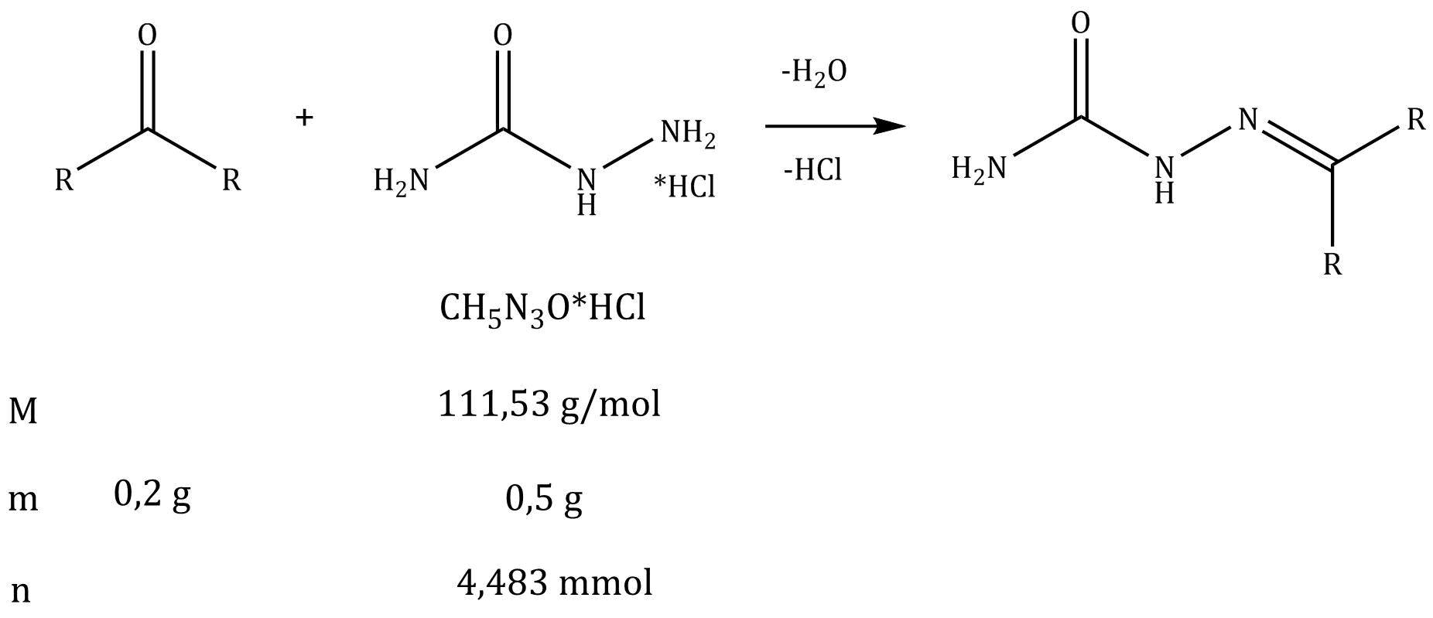

**Synthesis of the raw product:**

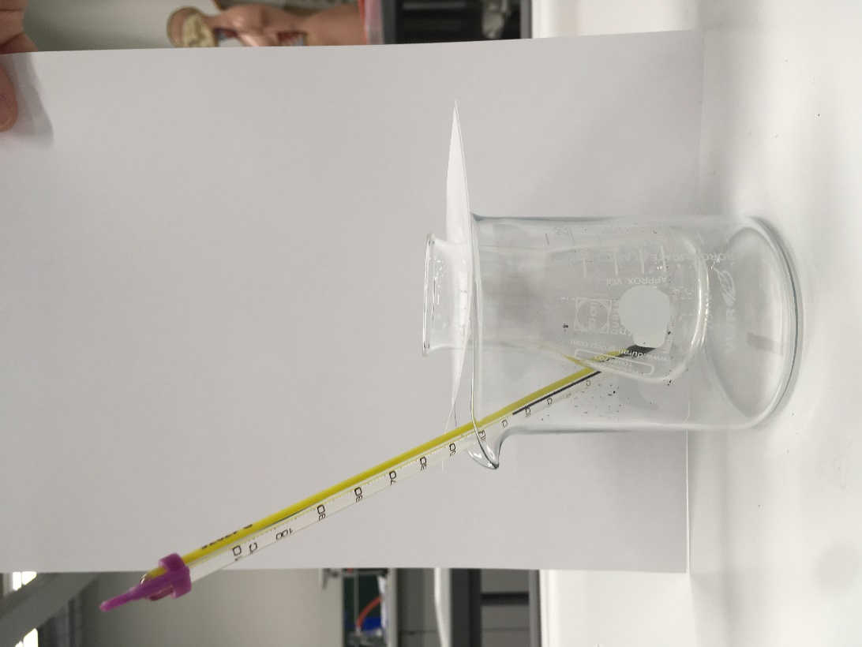

Dissolve 1g sodium acetate („NaAc“) in 3 mL water. One 50 mL Erlenmeyer flask contains 0.5 g semicarbazide hydrochloride. Add the sodium acetate solution to this and dissolve by stirring. Dissolve 0.2 g of the unknown carbonyl compound ( „E-Sy“) in 2-3 mL ethanol. Add it dropwise to the semicarbazide solution while stirring. After adding all the reagent, reflux the reaction for 15-30 min in the water bath at 70°C while constantly stirring (see figure on the previous page).

Place the product into an ice/water bath for 10 min. Suck the solution through a cleaned glass frit. Finally, wash it with very little aqueous ethanolic solution ca. 20% (*V*/*V*, prepare in measuring cylinder) and dry well by suction. Transfer a small amount of the product into an Eppendorf vial for further TLC analysis.

Hand your raw product to a lab supervisor, who will place it into a drying cabinet (100°C) for you. Request your raw product after 10 min. Use your tared watch glass for that purpose (state the mass).

|  |
| --- |
| 10.1 Show your raw product as well as the mass you measured in the weighing room to a lab supervisor for affirmation. |
| Mass tare: _____________________ Mass tare + raw product: _____________________  Mass raw product: ___________________ |

**Reprocessing and purification:**

Re-crystallize the raw product from ethanol („EtOH“). Use a 50 mL Erlenmeyer flask for that purpose. After crystallizing, dry the solid product by suction in a cleaned glass frit.

Hand your product to a lab supervisor, who will place it into a drying cabinet (100°C) for you. Request your product after 25 min. Use your tared watch glass for that purpose (state the mass).

|  |
| --- |
| 10.2 Show product as well as the mass you measured in the weighing room to a lab supervisor for affirmation. |
| Mass tare: _____________________ Mass tare + raw product: _____________________  Mass raw product: ___________________ |

Evaluation and control of purity:

Determine yield and melting point. The melting point will help you in determining which unknown carbonyl compound was your educt.

Melting points of different carbazones

|  |  |
| --- | --- |
| Semicarbazone of…. | Melting point semicarbazone product |
| Acetone (Propanone) | 189-190°C |
| Nonan-5-one | 90°C |
| Benzene carbaldehyde | 231°C |
| Acetophenone (1-Phenyl ethanone) | 208-210°C |
|  | 223°C |

|  |  |
| --- | --- |
| 10.3 Determine yield in g and % of theory. | |
|  | |
| 10.4 Determine the melting point and choose your unknown carbonyl compound from the list. Show your experiment for determining the melting point to a laboratory supervisor directly on the Kofler bench. | |
| Melting point: ________________  Unknown carbonyl compound: ______________________________________ | |

**Analysis**

While your product dries, carry out TLC analysis. Dissolve the educt (Eppendorf vial „TLC“), the raw product and the final product in ethyl ethanoate, respectively (i.e. in one Eppendorf vial each). Prepare and develop a TLC plate the usual way using ethyl ethanoate as the mobile phase. Interpret the TLC plate the usual way; Then hand the TLC to a laboratory supervisor. Mark the plate in the upper right corner with your lab place number. In case you do not succeed in preparing the TLC in the desired way, you can ask a laboratory supervisor to give you one (!) new TLC plate without losing points.

|  |
| --- |
| 10.5 Specify the following Rf values: |
| Rf-value of the educt: Rf- value of the product: Rf- value of the raw product: |

|  |
| --- |
| 10.6 Tick the correct statement(s) |
| The **Educt E** has □ lower □ higher Rf value, than the **Product P** , because …  □ **E** forms stronger H-bonds with silica gel.  □ **E** forms intramolecular H-bonds.  □ **P** forms stronger H-bonds with silica gel.  □ **P** has higher molar mass.  □ **P** is less polar.  □ **E** is less polar.  □ Silica gel is also polar.  □ Silica gel forms stronger interactions with **P**. |