41st Austrian Chemistry Olympiad

National Competition

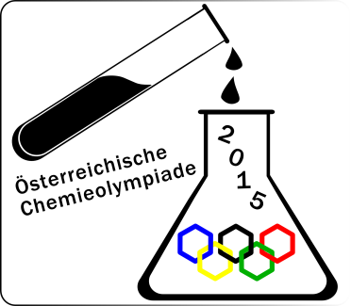

Solutions

Task 1 47/17 points
Quantitative Analysis

Titration volume chosen V₁ = 12.4 mL max12bp¹
Titration equation: Ag⁺ + Cl⁻ ⇄ AgCl 0.5bp
Equation for the indication reaction: 2 Ag⁺ + CrO₄²⁻ ⇄ Ag₂CrO₄ 1bp
Amount of chloride in the flask n₁ = 6.20 mmol 1bp
12.4·0.0500 = 0.620 mmol Ag⁺ = 0.620 mmol Cl⁻
0.620·10 = 6.20 mmol

Titration volume chosen V₂ = 16.85 ml max12bp²
Titration equation: 2 MnO₄⁻ + 5 C₂O₄²⁻ + 16 H⁺ ⇄ 2 Mn²⁺ + 10 CO₂ + 8 H₂O 1,5bp
concentration of the MnO₄⁻ -solution c = $0.0119$ mol/L 1bp
10.00·0.0500 = 0.500 mmol C₂O₄²⁻ ⇒ 0.200 mmol MnO₄⁻
$\frac{0.200}{16.85}=0.0119$ mol/L

Titration volume chosen V₃ = 9,90 mL max14bp³
amount oxalate n₃ = 0,2945 mmol 4bp
amount CaCl₂ in the flask n_{CaCl2} = 2,07 mmol
amount NaCl in the flask n_{NaCl} = $2,06$ mmol
mass CaCl₂ in the flask m_{CaCl2} = 228 mg
mass NaCl in the flask m_{NaCl} = 121 mg
composition in percent: 65.3% CaCl₂ + 34.7% NaCl
$V_{2}-V_{3}=V\left(permanganate for CaC_{2}O_{4}\right)=6.95$ mL
6.95·0.0119·2.5 = 0.2068 mmol ⇒ 2.07 mmol CaCl₂ in the flask
$n_{NaCl}=6.20-2∙2.068=2.064$ mmol

¹ $12 bP:≤±0.2$ mL; $0 bP:>±0.8$ mL; in between: $bp=12-\frac{12}{0.6}∙\left(\left|V_{master}-V_{1}\right|-0.2\right)$

² $12 bP:≤±0.15$ mL; $0 bP:>±0.65$ mL; in between: $bp=12-\frac{12}{0.50}∙\left(\left|V_{master}-V_{1}\right|-0.15\right)$

³ $14 bP:≤±0.3$ mL; $0 bP:>±1.0$ mL; in between: $bp=14-\frac{14}{0.7}∙\left(\left|V_{master}-V_{1}\right|-0.3\right)$

Task 2 29/11 points

Photometric Analysis of a Coordination Compound

2.1. Fill in the concentrations and the measured absorptions.
Nr. | c(Fe³⁺)/  mmolL⁻¹ | c(SCN⁻)/  mmolL⁻¹ | A (447nm) | Nr. | c(Fe³⁺)/  mmolL⁻¹ | c(SCN⁻)/  mmolL⁻¹ | A (447nm)
1 | 2.40 | 0 | 0.001 | 6 | 0.40 | 2.00 | 0.463
2 | 2.00 | 0.40 | 0.429
3 | 1.60 | 0.80 | 0.712
4 | 1.20 | 1.20 | 0.817
5 | 0.80 | 1.60 | 0.731 | 7 | 0 | 2.40 | 0.003
for each measurement 2bp, maximum 14bp
2.2. Job-Plot for the evaluation max. 10bp
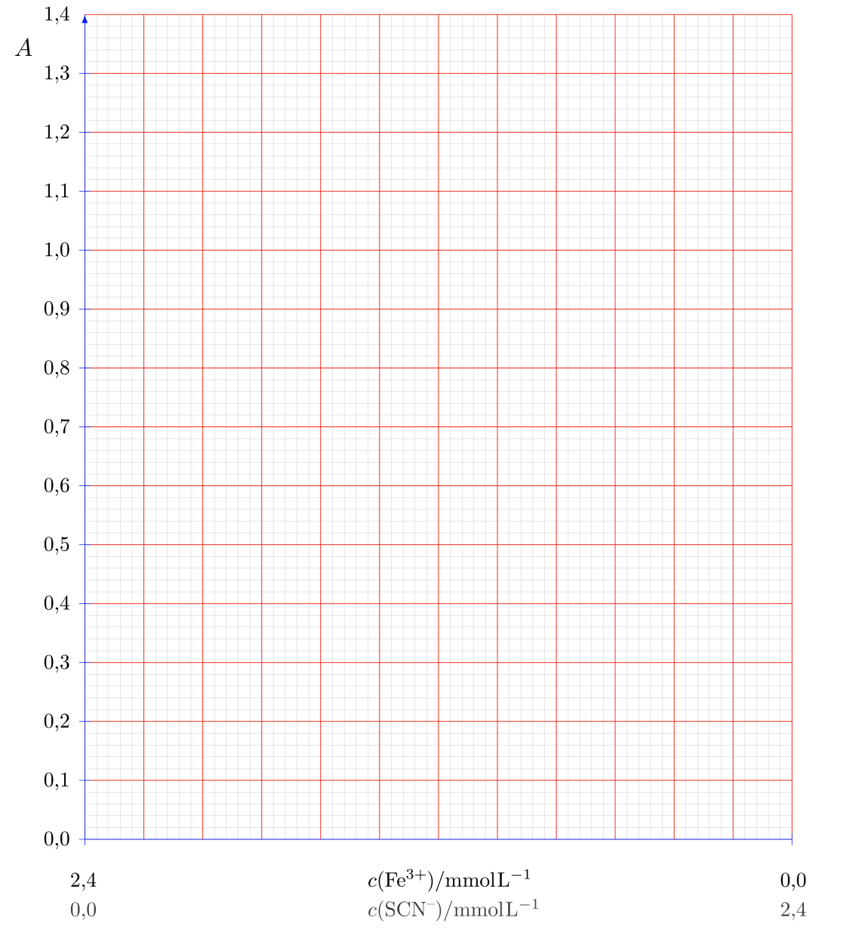

2.3. Stoichiometry of the complex [Fe(SCN)_{x}]^{(3-x)+} – as can be read from the Job-plot.
x = 1 1bp

2.4. Calculation of the formation constant using the plot.
Formation constant K = 3335
Show your calculation of K:

tangents in the diagram → right extrapolation of the peak value 1bp
right calculation of K 3bp

peak value : A’ = 1.34 → $ε=A^{'}/c_{0}d$

Absorption at the stoichiometric proportion A = 0.817 → $c=\frac{A}{εd}=c_{0}⋅\frac{A}{A^{'}}$

c₀ at the stoichiometric proportion: ${\text{1.20⋅10}}^{-3}\text{ mol⋅}{\text{L}}^{\text{-1}}$.

$$K=\frac{{\left[Fe\left(SCN\right)\right]}^{2+}}{\left[Fe^{3+}\right][SCN^{-}]}=\frac{c}{{(c}_{0}-{c)}^{2}}=\frac{ c_{0}⋅\frac{A}{A^{'}}}{{\left(c_{0}-c_{0}\frac{A}{A^{'}}\right)}^{2}}= \frac{1}{c_{0}}⋅\frac{ \frac{A}{A^{'}}}{{\left(1-\frac{A}{A^{'}}\right)}^{2}}=\frac{1}{1.2⋅{10}^{-3}}⋅\frac{ \frac{0.817}{1.34}}{{\left(1-\frac{0.817}{1.34}\right)}^{2}}=3335$$

Task 3 23/11 points

Synthesis of 2-iodobenzoic acid

3.1. Hand in the product on the petri-dish:
light yellow crystals……3 bp
other appearence……0-2 bp

3.2. Calculate the theoretical yield: 1 bp
Calculation:
1 mol anthranilic acid (137 g/mol) gives 1 mol of product (248 g/mol),
2.00 g of starting material give 3,62 g of product

3.3. Calculate your yield in g and in % of the theory:
Calculation:
no product: 0 bp
≥ 2.20 g: 15 bp, in between 0 and 2.20 g: $bp=15-\frac{15}{2.20}∙(2.20-m)$
$\%=\frac{m_{OWN}}{3.62}∙100$ 1 bp

3.4. Melting point of your product:

t_{M}= 161-162°C: 3 bp; t_{M} = 160°-159°C: 2 bp; t_{M} = 158°-157°C: 1 bp;

